**Speak Out Membership Form 2019 – 2021**

Speak Out members can

* Vote in Speak Out elections
* Be on the Members’ Executive
* Change the Speak Out Constitution

**How to use this form**

  **Tick boxes are marked with tick symbol**

**  Writing boxes are marked with a pen symbol**

**Your Contact Details**

**Title:**

MR MRS MISS



I choose not to say

_______________________________________________________

What is your full name?



_______________________________________________________

What is the address where you live?

 

Town and City 

 Post code 

Telephone Number 

Write your email address if you would like us to contact you by email.

 

About you

Are you a male? Are you a female?

What is your date of Birth?

Day Month Year





Do you have a disability that affects your learning?

 Yes  No

_______________________________________________________

When you send us your information you agree:

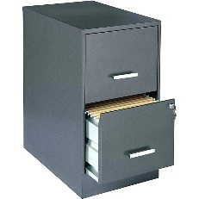

* We can store your information safely at Speak Out



* We can use your information to contact you about your Speak Out Membership
* We can use your information when there are other things about Speak Out we need to tell you.

Our duty is to make sure we follow the Privacy Act

The Privacy Act is **a** law saying what we must do with information to keep it safe.

**To join please complete the form and post to:**

Speak Out

PO Box 4578

Bathurst Street Post Office

Hobart 7000

**Membership is free and is for 2 years**

Sign to say you want to be a member

